Experiment 12: Port Scanning Tools in Kali Linux
Aim
To study and execute port scanning commands in Kali Linux to identify open ports and determine the services running on a target system.
Algorithm
- Start Kali Linux and open the terminal.
- Check whether Nmap is installed.
- Scan the local machine to identify open ports.
- Perform a scan to detect services running on open ports.
- Display and observe the scan results.
Commands and Uses
1. Scan common ports
nmap 127.0.0.1
Use: Scans the most common ports on the local machine.
2. Scan all TCP ports
nmap -p- 127.0.0.1
Use: Scans TCP ports from 1 to 65535.
3. Detect open ports and services
nmap -sV 127.0.0.1
Use: Identifies open ports and attempts to determine the services and their versions.
4. Scan specific ports
nmap -p 22,80,443 127.0.0.1
Use: Checks ports 22 (SSH), 80 (HTTP), and 443 (HTTPS).
Sample Output
Nmap scan report for localhost (127.0.0.1)
Host is up.

PORT STATE SERVICE
22/tcp closed ssh
80/tcp closed http
443/tcp closed https
Note: This is example output. Your actual results depend on the services running on your machine.
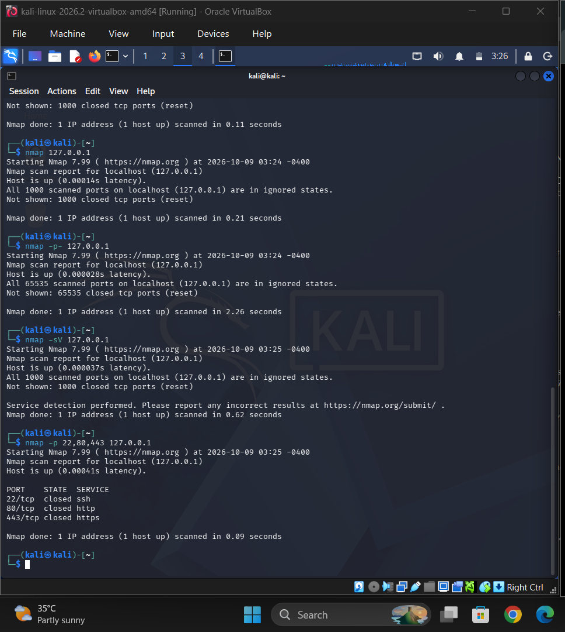
Result
Port scanning commands were studied and executed using Nmap in Kali Linux to identify open ports and detect services on the target system.
Safety: Scan only your own systems or systems for which you have permission.

